Report – Data harmonization for Spain

**Encoding**

All variables were coded as for HEROES codebook

**Merging**

The Spain data set was merged with tables “Region_Mobility_Report” by *time* and *NUTS 3*. It was already merged with with tables “NUTS” and with stringency index*.*

**Missing values**

Some **social characteristics** are NAs in wave 2 and 3 because the data set is in long format (e.g. age, profession).

Some **variables are missing for each waves** (sd08new, ra and some mobility variables) and some of them only for wave 1 (pcptsd) or wave 1 and 2 (GAD-7).

Some information of **“Region_Mobility_Report”** are missing (e.g. iso_3166_2_code, metro_area, census_fips_code).

**Results**

You can find below a simple view of **main descriptive results by wave** and **graphs of missing values per wave** using the function vismiss()

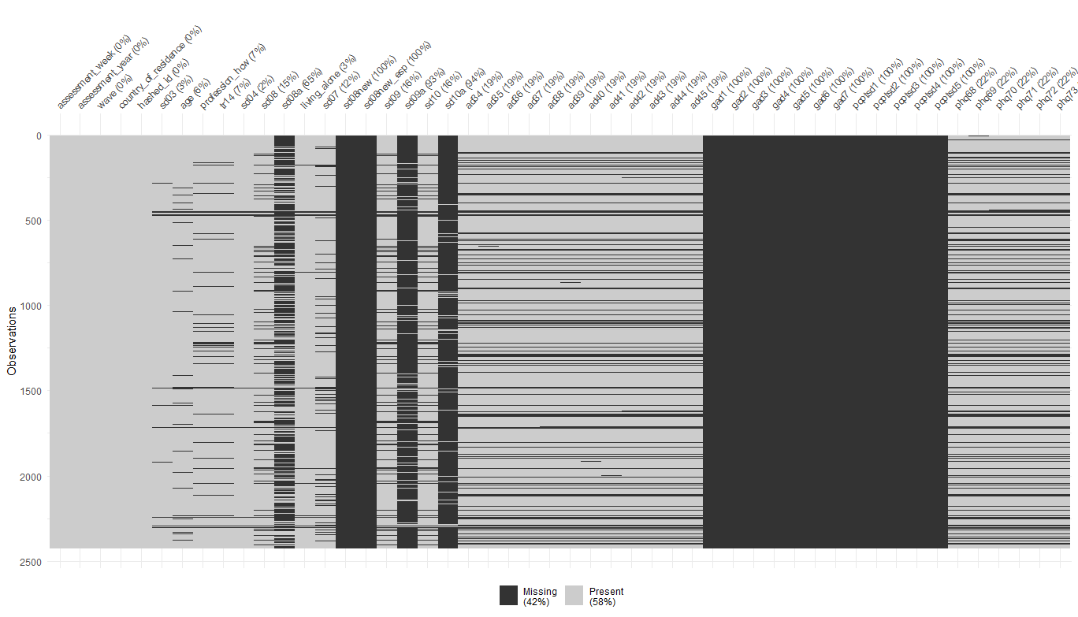Wave 1

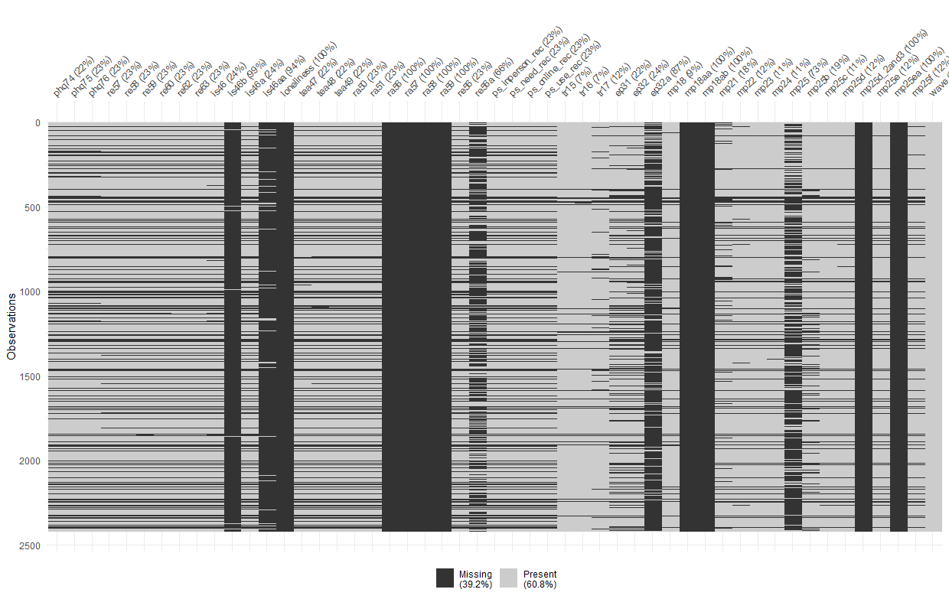

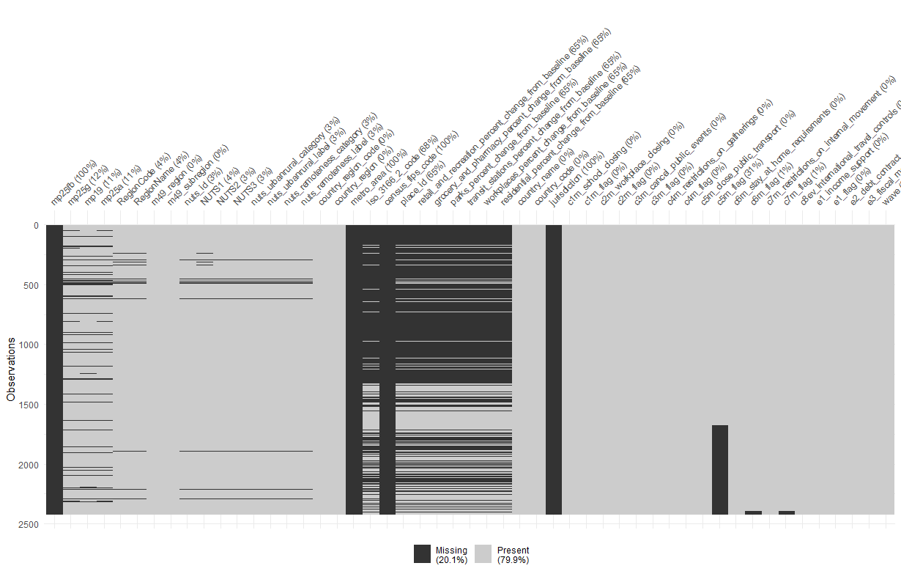

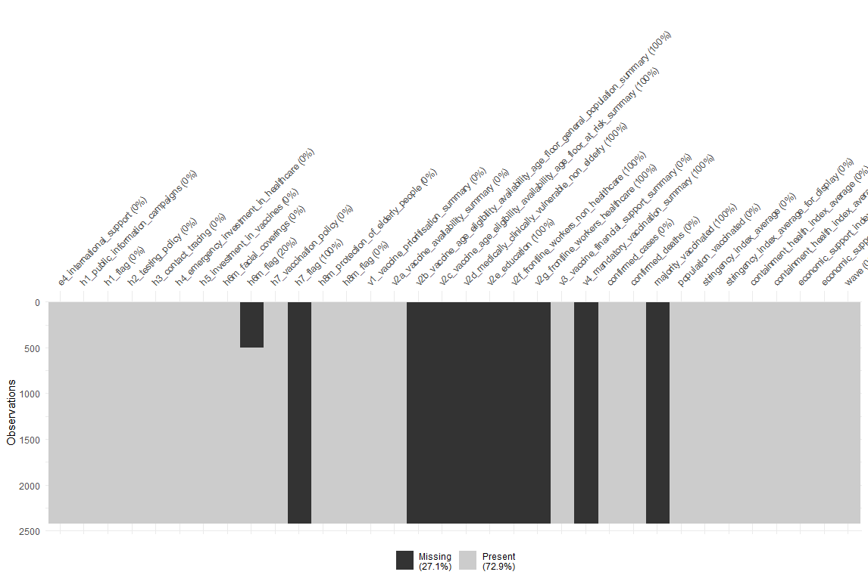

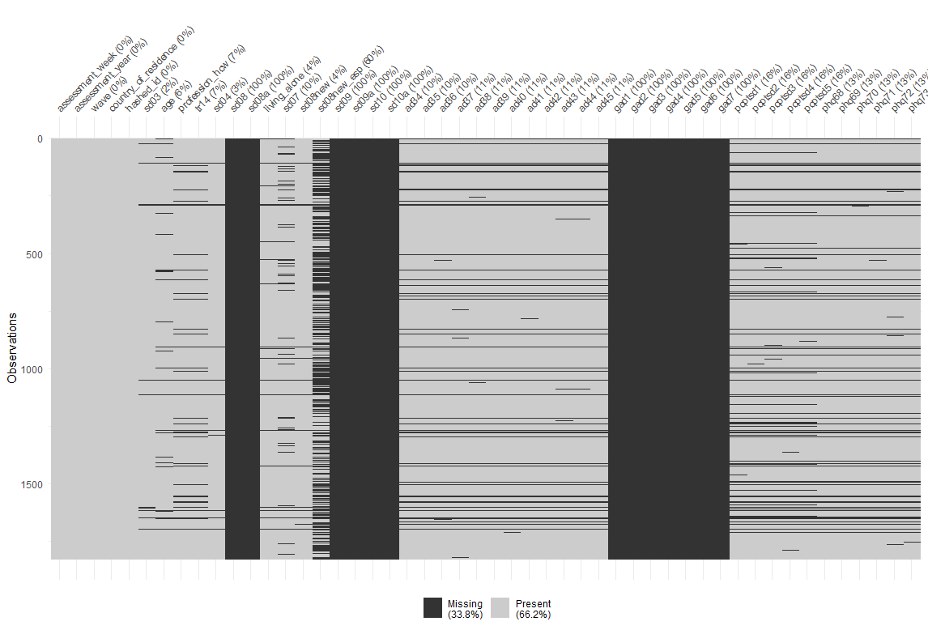Wave 2

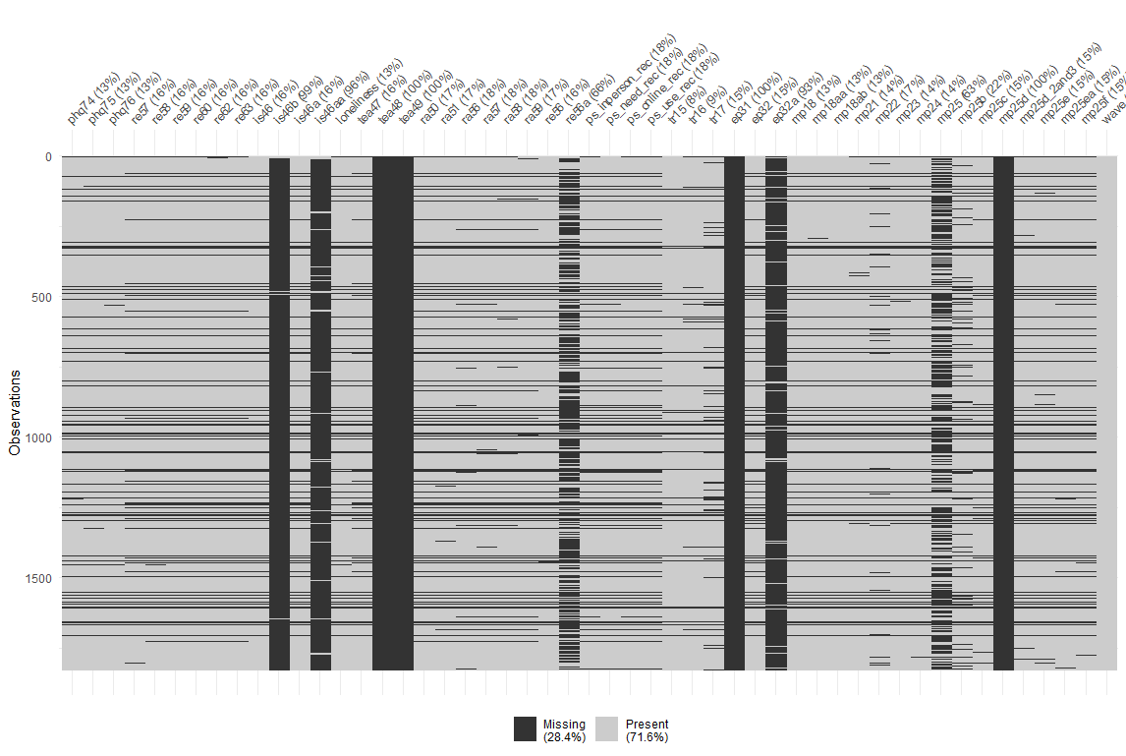

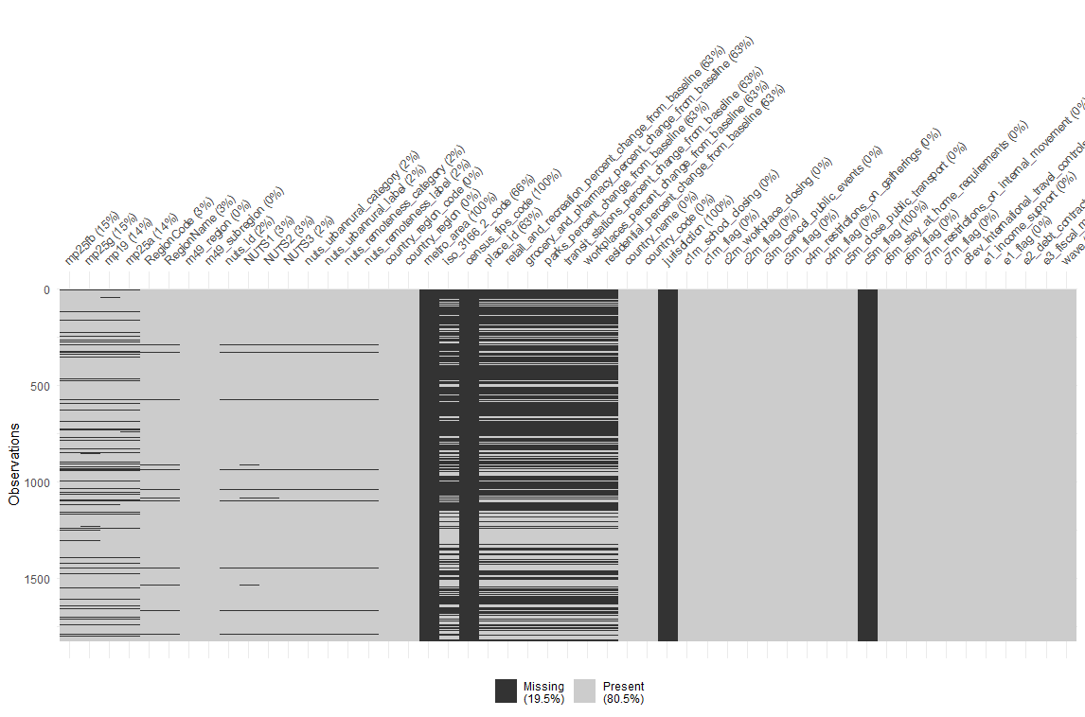

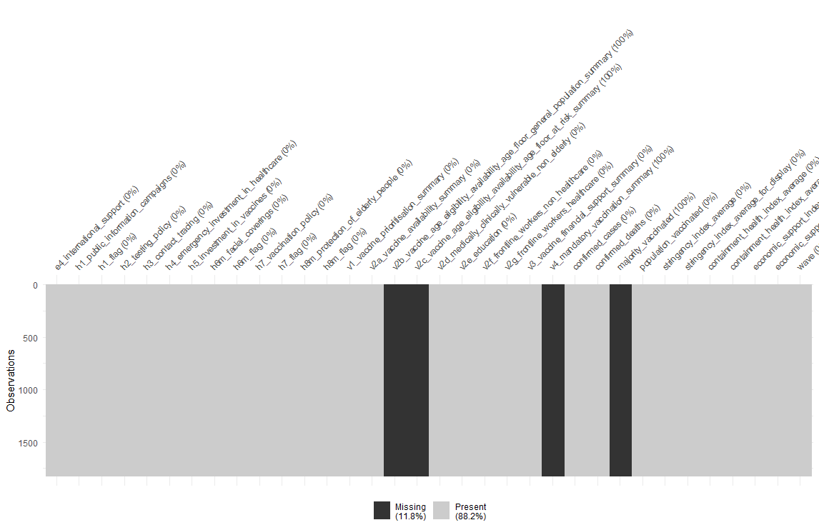

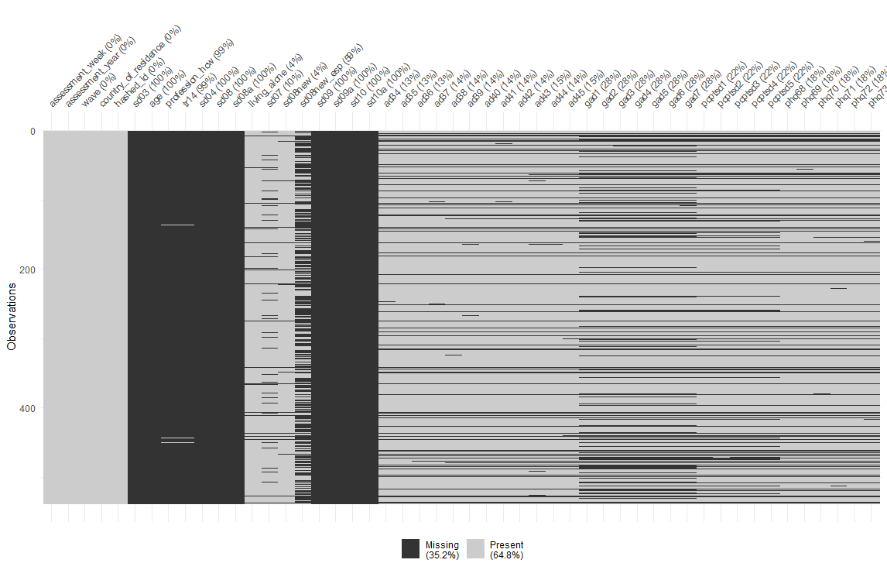Wave 3

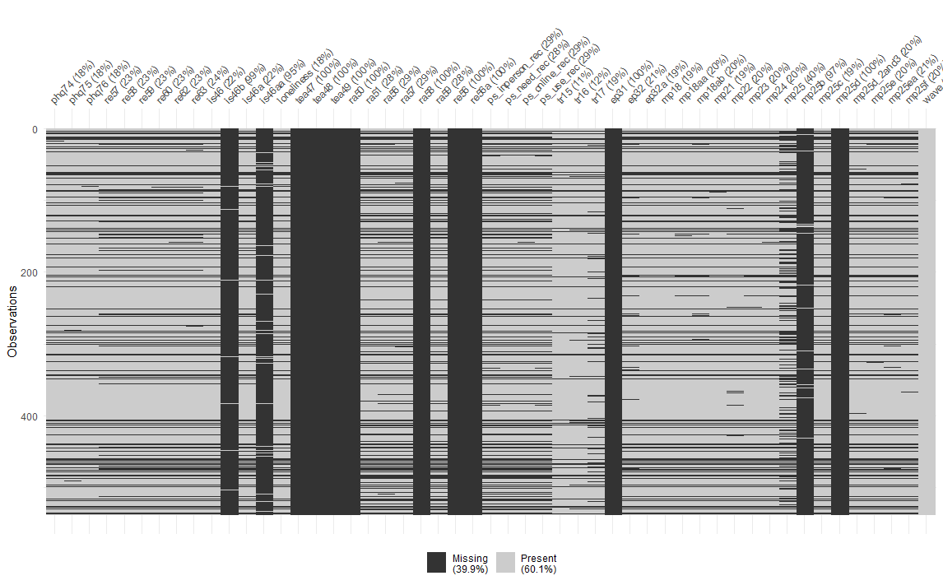

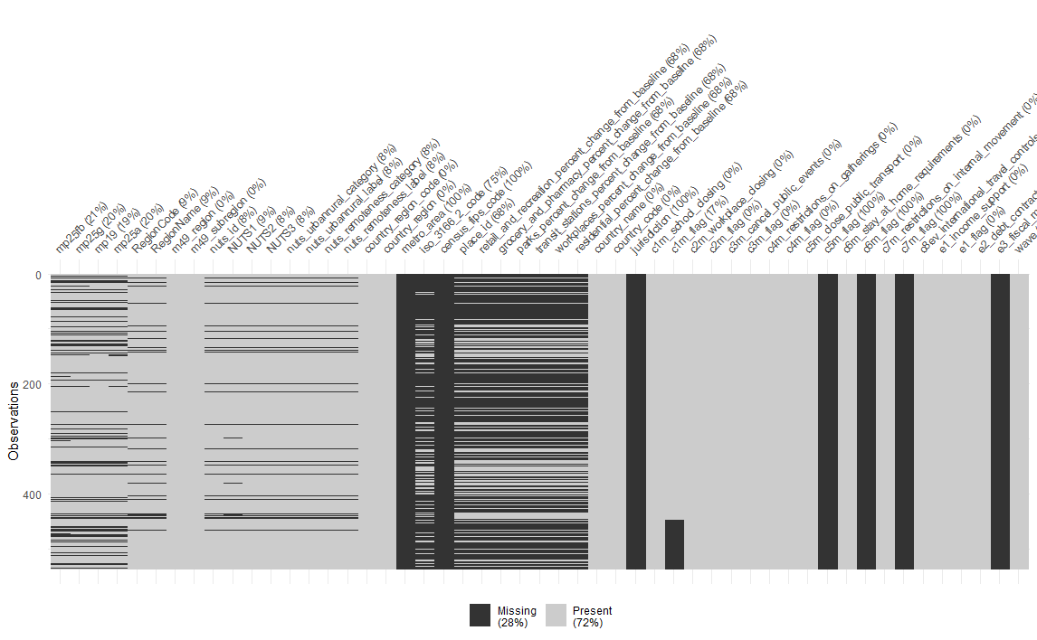

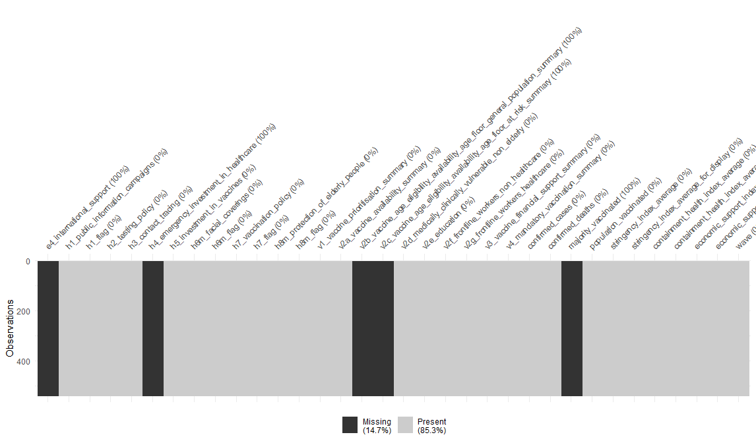

*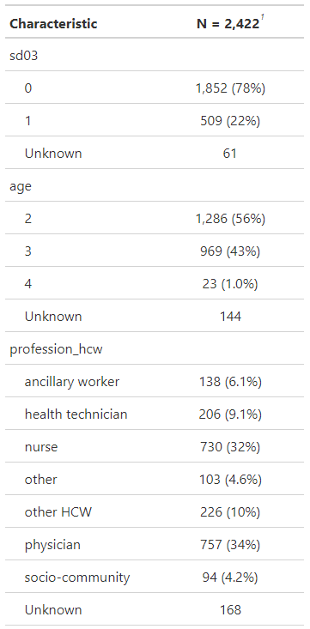 Wave 1 Wave 2 Wave 3*



